**AIM: To Study Audio, Video And Location on Android.**

* **THEORY:**
  + **MediaRecorder:**

1. It is used to record audio and video. The recording control is based on a simple state machine.
2. The Android multimedia framework provides built-in support for capturing and encoding common audio and video formats.
3. After recording the media, we can create a sound file that can be played later.
4. In order to use MediaRecorder class ,you will first create an instance of MediaRecorder class.
5. Syntax :

MediaRecorder myAudioRecorder = new MediaRecorder();

1. Some of the methods used in MediaRecorder:
   1. setAudioSource():This method specifies the source of audio to be recorded
   2. setVideoSource():This method specifies the source of video to be recorded.
   3. setOutputFormat():This method specifies the audio format in which audio to be stored.
   4. setAudioEncoder():This method specifies the audio encoder to be used.
   5. setOutputFile():This method configures the path to the file into which the recorded audio is to be stored.
   6. stop():This method stops the recording process.
   7. release():This method should be called when the recorder instance is needed.
   * **Location:**
2. A data class representing a geographic location.
3. The Location object represents a geographic location which can consist of a latitude, longitude, time stamp, and other information such as bearing, altitude and velocity.
4. All locations generated through LocationManager are guaranteed to have a valid latitude, longitude, and timestamp (both UTC time and elapsed real-time since boot).
5. Methods of this object are:
   1. float distanceTo(Location dest)- Returns the approximate distance in meters between this location and the given location.
   2. float getAccuracy()- Get the estimated accuracy of this location, in meters.
   3. double getAltitude()- Get the altitude if available, in meters above sea level.
   4. float getBearing()- Get the bearing, in degrees.
   5. double getLatitude()- Get the latitude, in degrees.
   6. double getLongitude()- Get the longitude, in degrees.

**A) Write a program to:**

**a) Record an audio and play it.**

**b) Play a video in a video view.**

* **CODE:**
  + **AndroidManifest.xml:**

<?xml version="1.0" encoding="utf-8"?>  
<manifest xmlns:android="http://schemas.android.com/apk/res/android"  
 package="com.example.practical6_a">  
 <uses-permission android:name="android.permission.INTERNET" />  
 <uses-permission android:name="android.permission.RECORD_AUDIO" />  
 <uses-permission android:name="android.permission.WRITE_EXTERNAL_STORAGE"/>  
 <uses-permission android:name="android.permission.STORAGE" />  
 <application  
 android:allowBackup="true"  
 android:icon="@mipmap/ic_launcher"  
 android:label="@string/app_name"  
 android:roundIcon="@mipmap/ic_launcher_round"  
 android:supportsRtl="true"  
 android:theme="@style/Theme.Practical6_A">  
 <activity  
 android:name=".MainActivity"  
 android:exported="true">  
 <intent-filter>  
 <action android:name="android.intent.action.MAIN" />  
  
 <category android:name="android.intent.category.LAUNCHER" />  
 </intent-filter>  
 </activity>  
 </application>  
  
</manifest>

* + **activity_main.xml:**

<?xml version="1.0" encoding="utf-8"?>  
<androidx.constraintlayout.widget.ConstraintLayout xmlns:android="http://schemas.android.com/apk/res/android"  
 xmlns:app="http://schemas.android.com/apk/res-auto"  
 xmlns:tools="http://schemas.android.com/tools"  
 android:layout_width="match_parent"  
 android:layout_height="match_parent"  
 tools:context=".MainActivity">  
  
 <Button  
 android:id="@+id/button5"  
 android:layout_width="96dp"  
 android:layout_height="55dp"  
 android:text="PLAY"  
 app:layout_constraintBottom_toBottomOf="parent"  
 app:layout_constraintEnd_toEndOf="parent"  
 app:layout_constraintHorizontal_bias="0.295"  
 app:layout_constraintStart_toStartOf="parent"  
 app:layout_constraintTop_toTopOf="parent"  
 app:layout_constraintVertical_bias="0.318" />  
  
 <Button  
 android:id="@+id/button4"  
 android:layout_width="96dp"  
 android:layout_height="55dp"  
 android:text="STOP PLAY"  
 app:layout_constraintBottom_toBottomOf="parent"  
 app:layout_constraintEnd_toEndOf="parent"  
 app:layout_constraintHorizontal_bias="0.717"  
 app:layout_constraintStart_toStartOf="parent"  
 app:layout_constraintTop_toTopOf="parent"  
 app:layout_constraintVertical_bias="0.318" />  
  
 <Button  
 android:id="@+id/button3"  
 android:layout_width="96dp"  
 android:layout_height="55dp"  
 android:text="PLAY VIDEO"  
 app:layout_constraintBottom_toBottomOf="parent"  
 app:layout_constraintEnd_toEndOf="parent"  
 app:layout_constraintHorizontal_bias="0.498"  
 app:layout_constraintStart_toStartOf="parent"  
 app:layout_constraintTop_toTopOf="parent"  
 app:layout_constraintVertical_bias="0.458" />  
  
 <Button  
 android:id="@+id/button2"  
 android:layout_width="96dp"  
 android:layout_height="55dp"  
 android:text="STOP RECORD"  
 app:layout_constraintBottom_toBottomOf="parent"  
 app:layout_constraintEnd_toEndOf="parent"  
 app:layout_constraintHorizontal_bias="0.717"  
 app:layout_constraintStart_toStartOf="parent"  
 app:layout_constraintTop_toTopOf="parent"  
 app:layout_constraintVertical_bias="0.176" />  
  
 <TextView  
 android:id="@+id/textView"  
 android:layout_width="294dp"  
 android:layout_height="37dp"  
 android:text="AUDIO AND VIDEO"  
 android:textAlignment="center"  
 android:textSize="30sp"  
 android:textStyle="bold"  
 app:layout_constraintBottom_toBottomOf="parent"  
 app:layout_constraintEnd_toEndOf="parent"  
 app:layout_constraintHorizontal_bias="0.495"  
 app:layout_constraintStart_toStartOf="parent"  
 app:layout_constraintTop_toTopOf="parent"  
 app:layout_constraintVertical_bias="0.023" />  
  
 <VideoView  
 android:id="@+id/videoView"  
 android:layout_width="365dp"  
 android:layout_height="293dp"  
 app:layout_constraintBottom_toBottomOf="parent"  
 app:layout_constraintEnd_toEndOf="parent"  
 app:layout_constraintHorizontal_bias="0.549"  
 app:layout_constraintStart_toStartOf="parent"  
 app:layout_constraintTop_toTopOf="parent"  
 app:layout_constraintVertical_bias="0.904" />  
  
 <Button  
 android:id="@+id/button"  
 android:layout_width="96dp"  
 android:layout_height="55dp"  
 android:text="RECORD"  
 app:layout_constraintBottom_toBottomOf="parent"  
 app:layout_constraintEnd_toEndOf="parent"  
 app:layout_constraintHorizontal_bias="0.295"  
 app:layout_constraintStart_toStartOf="parent"  
 app:layout_constraintTop_toTopOf="parent"  
 app:layout_constraintVertical_bias="0.176" />  
</androidx.constraintlayout.widget.ConstraintLayout>

* + **MainActivity.java:**

package com.example.practical6_a;  
  
import static android.Manifest.permission.*RECORD_AUDIO*;  
import static android.Manifest.permission.*WRITE_EXTERNAL_STORAGE*;  
import androidx.appcompat.app.AppCompatActivity;  
import androidx.core.app.ActivityCompat;  
import androidx.core.content.ContextCompat;  
import android.annotation.SuppressLint;  
import android.content.pm.PackageManager;  
import android.media.MediaPlayer;  
import android.media.MediaRecorder;  
import android.net.Uri;  
import android.os.Bundle;  
import android.os.Environment;  
import android.util.Log;  
import android.view.View;  
import android.widget.Button;  
import android.widget.MediaController;  
import android.widget.Toast;  
import android.widget.VideoView;  
import java.io.IOException;  
import java.util.Random;  
  
public class MainActivity extends AppCompatActivity {  
 Button buttonStart, buttonStop, buttonPlayLastRecordAudio, playvideo,buttonStopPlayingRecording ;  
 String AudioSavePathInDevice = null;  
 MediaRecorder mediaRecorder ;  
 Random random ;  
 VideoView vw;  
  
 String RandomAudioFileName = "ABCDEFGHIJKLMNOP";  
 public static final int *RequestPermissionCode* = 1;  
 MediaPlayer mediaPlayer ;  
  
 @Override  
 protected void onCreate(Bundle savedInstanceState) {  
 super.onCreate(savedInstanceState);  
 setContentView(R.layout.*activity_main*);  
 vw = findViewById(R.id.*videoView*);  
 buttonStart = (Button) findViewById(R.id.*button*);  
 buttonStop = (Button) findViewById(R.id.*button2*);  
 buttonPlayLastRecordAudio = (Button) findViewById(R.id.*button5*);  
 buttonStopPlayingRecording = (Button)findViewById(R.id.*button4*);  
 playvideo=findViewById(R.id.*button3*);  
 buttonStop.setEnabled(false);  
 buttonPlayLastRecordAudio.setEnabled(false);  
 buttonStopPlayingRecording.setEnabled(false);  
  
 random = new Random();  
 playvideo.setOnClickListener(new View.OnClickListener() {  
 @Override  
 public void onClick(View view) {  
 Toast.*makeText*(MainActivity.this, "STARTING VIDEO", Toast.*LENGTH_LONG*).show();  
 Uri vidUri = Uri.*parse*("https://ia800201.us.archive.org/22/items/ksnn_compilation_master_the_internet/ksnn_compilation_master_the_internet_512kb.mp4");  
 vw = findViewById(R.id.*videoView*);  
 vw.setVideoURI(vidUri);  
 vw.setMediaController(new MediaController(MainActivity.this));  
 vw.requestFocus();  
 vw.start();  
 }  
 });  
 buttonStart.setOnClickListener(new View.OnClickListener() {  
 @Override  
 public void onClick(View view) {  
  
 if(checkPermission()) {  
  
 AudioSavePathInDevice =  
 Environment.*getExternalStorageDirectory*().getAbsolutePath() + "/" +  
 CreateRandomAudioFileName(5) + "AudioRecording.3gp";  
  
 MediaRecorderReady();  
  
 try {  
 mediaRecorder.prepare();  
 mediaRecorder.start();  
 Toast.*makeText*(MainActivity.this, "Recording started", Toast.*LENGTH_LONG*).show();  
 } catch (IllegalStateException e) {  
 // *TODO Auto-generated catch block* e.printStackTrace();  
 } catch (IOException e) {  
 // *TODO Auto-generated catch block* e.printStackTrace();  
 }  
  
 buttonStart.setEnabled(false);  
 buttonStop.setEnabled(true);  
  
  
 } else {  
 requestPermission();  
 }  
 }  
 });  
  
 buttonStop.setOnClickListener(new View.OnClickListener() {  
 @Override  
 public void onClick(View view) {  
 mediaRecorder.stop();  
 buttonStop.setEnabled(false);  
 buttonPlayLastRecordAudio.setEnabled(true);  
 buttonStart.setEnabled(true);  
 buttonStopPlayingRecording.setEnabled(false);  
  
 Toast.*makeText*(MainActivity.this, "Recording Completed",  
 Toast.*LENGTH_LONG*).show();  
 }  
 });  
  
 buttonPlayLastRecordAudio.setOnClickListener(new View.OnClickListener() {  
 @Override  
 public void onClick(View view) throws IllegalArgumentException,  
 SecurityException, IllegalStateException {  
  
 buttonStop.setEnabled(false);  
 buttonStart.setEnabled(false);  
 buttonStopPlayingRecording.setEnabled(true);  
 mediaPlayer = new MediaPlayer();  
 try {  
 mediaPlayer.setDataSource(AudioSavePathInDevice);  
 mediaPlayer.prepare();  
 } catch (IOException e) {  
 e.printStackTrace();  
 }  
 mediaPlayer.start();  
 Toast.*makeText*(MainActivity.this, "Recording Playing",  
 Toast.*LENGTH_LONG*).show();  
 }  
 });  
 buttonStopPlayingRecording.setOnClickListener(new View.OnClickListener() {  
 @Override  
 public void onClick(View view) {  
 buttonStop.setEnabled(false);  
 buttonStart.setEnabled(true);  
 buttonStopPlayingRecording.setEnabled(false);  
 buttonPlayLastRecordAudio.setEnabled(true);  
  
 if(mediaPlayer != null){  
 mediaPlayer.stop();  
 mediaPlayer.release();  
 MediaRecorderReady();  
 }  
 }  
 });  
 }  
 public void MediaRecorderReady(){  
 mediaRecorder=new MediaRecorder();  
 mediaRecorder.setAudioSource(MediaRecorder.AudioSource.*MIC*);  
 mediaRecorder.setOutputFormat(MediaRecorder.OutputFormat.*THREE_GPP*);  
 mediaRecorder.setAudioEncoder(MediaRecorder.AudioEncoder.*AMR_NB*);  
 mediaRecorder.setOutputFile(AudioSavePathInDevice);  
 }  
 public String CreateRandomAudioFileName(int string){  
 StringBuilder stringBuilder = new StringBuilder( string );  
 int i = 0 ;  
 while(i < string ) {  
 stringBuilder.append(RandomAudioFileName.  
 charAt(random.nextInt(RandomAudioFileName.length())));  
  
 i++ ;  
 }  
 return stringBuilder.toString();  
 }  
 private void requestPermission() {  
 ActivityCompat.*requestPermissions*(MainActivity.this, new  
 String[]{*WRITE_EXTERNAL_STORAGE*, *RECORD_AUDIO*}, *RequestPermissionCode*);  
 }  
 public void onRequestPermissionsResult(int requestCode, String permissions[], int[] grantResults) {  
 super.onRequestPermissionsResult(requestCode, permissions, grantResults);  
 switch (requestCode) {  
 case *RequestPermissionCode*:  
 if (grantResults.length > 0) {  
 boolean StoragePermission = grantResults[0] ==  
 PackageManager.*PERMISSION_GRANTED*;  
 boolean RecordPermission = grantResults[1] ==  
 PackageManager.*PERMISSION_GRANTED*;  
  
 if (StoragePermission && RecordPermission) {  
 Toast.*makeText*(MainActivity.this, "Permission Granted",  
 Toast.*LENGTH_LONG*).show();  
 } else {  
 Toast.*makeText*(MainActivity.this, "Permission Denied", Toast.*LENGTH_LONG*).show();  
 }  
 }  
 break;  
 }  
 }  
 public boolean checkPermission() {  
 int result = ContextCompat.*checkSelfPermission*(getApplicationContext(),  
 *WRITE_EXTERNAL_STORAGE*);  
 int result1 = ContextCompat.*checkSelfPermission*(getApplicationContext(),  
 *RECORD_AUDIO*);  
 return result == PackageManager.*PERMISSION_GRANTED* &&  
 result1 == PackageManager.*PERMISSION_GRANTED*;  
 }  
}

* **OUTPUT:**
  + **GUI Recording Started**

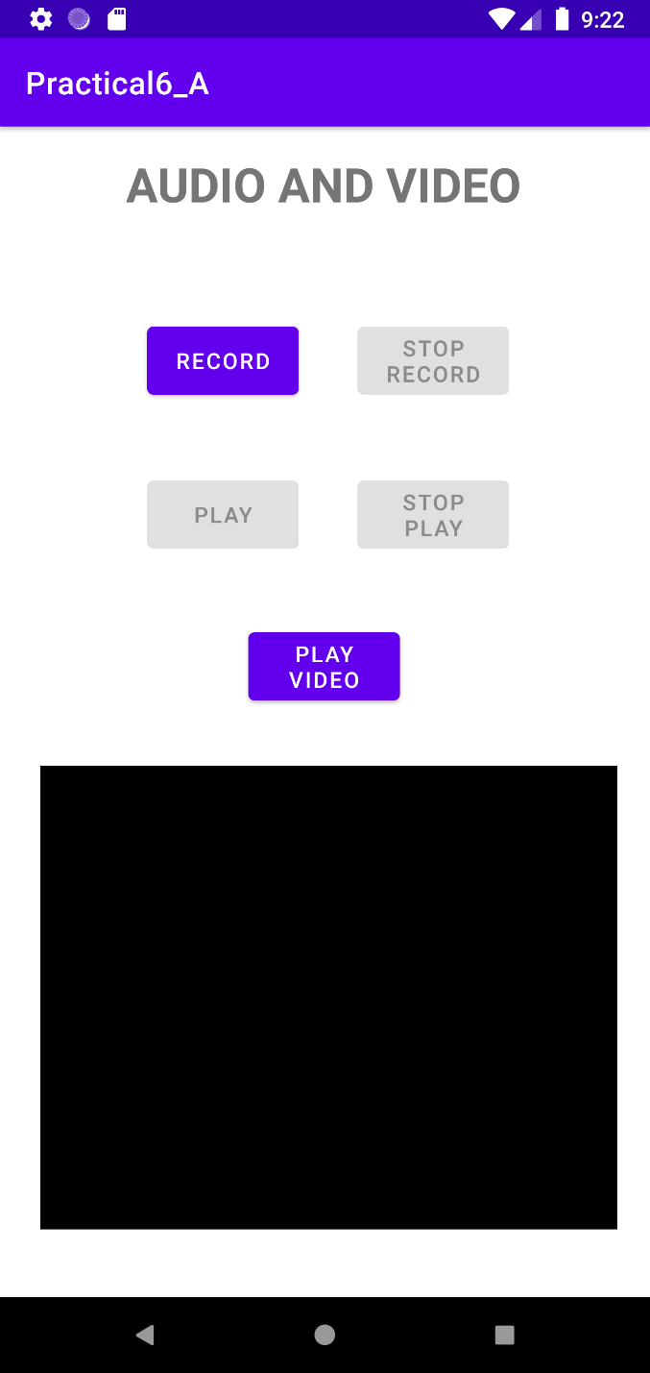 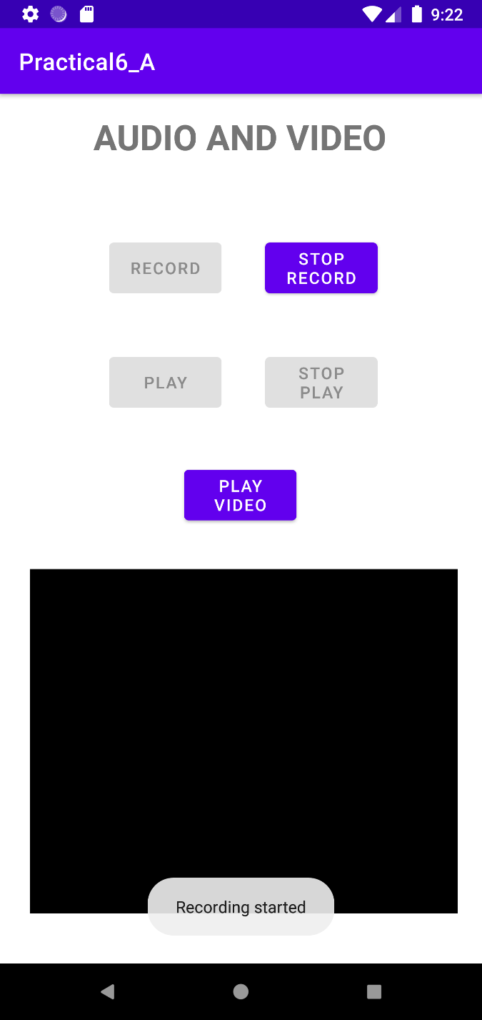

* + **Recording Completed Recording Playing**

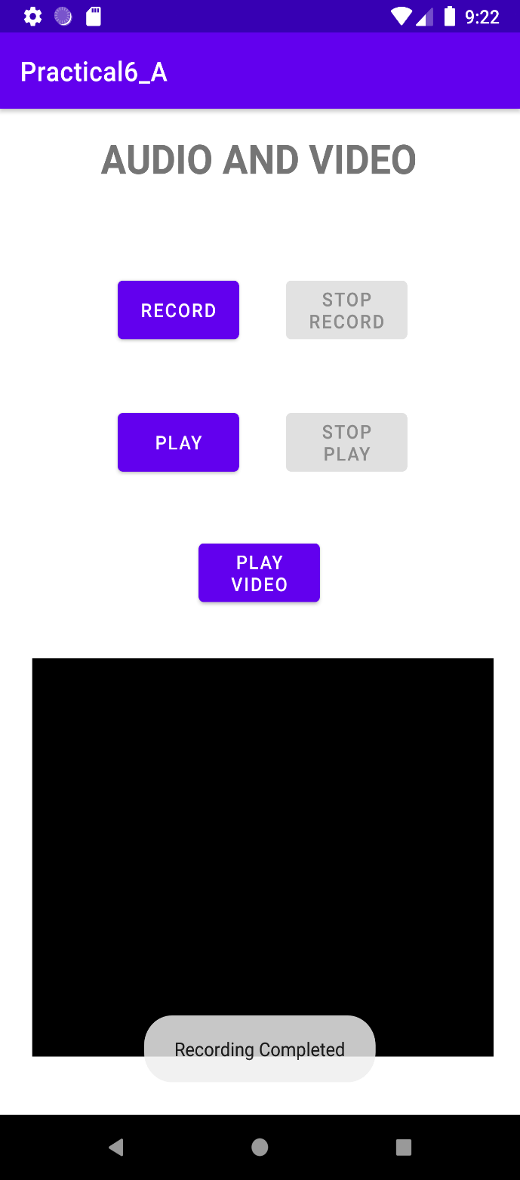 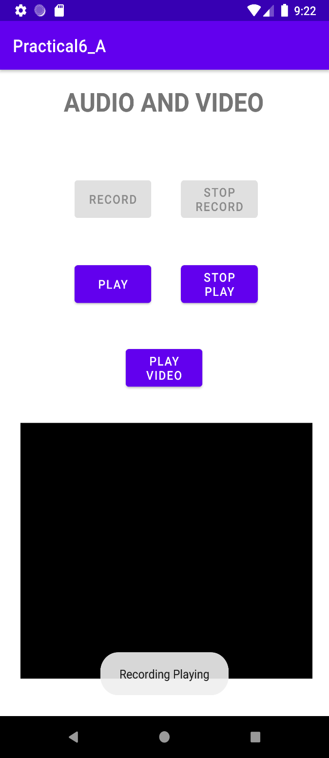

* + **Starting Video Video Playing**

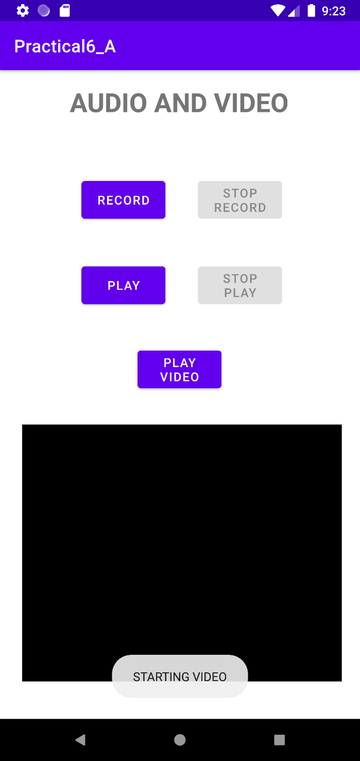 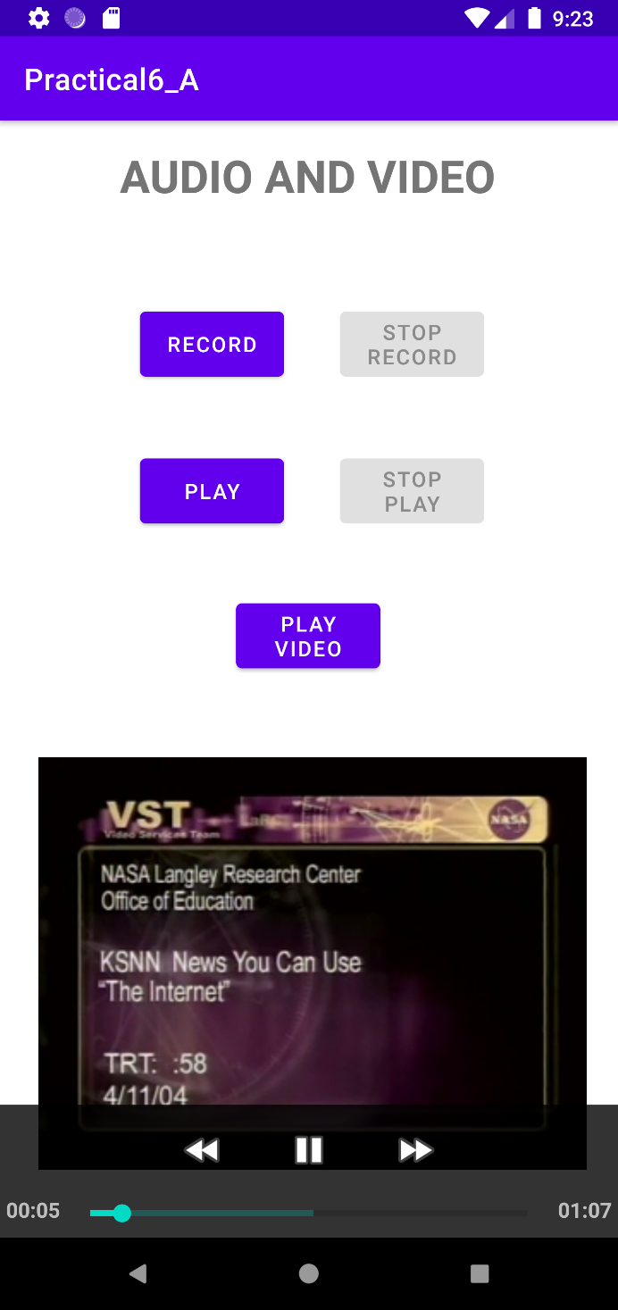

**B) Create an application to display the current location of your device. (Latitude & Longitude value):**

* **CODE:**
  + **AndroidManifest.xml:**

<?xml version="1.0" encoding="utf-8"?>  
<manifest xmlns:android="http://schemas.android.com/apk/res/android"  
 package="com.example.practical6b">  
 <uses-permission android:name="android.permission.ACCESS_FINE_LOCATION"/>  
 <uses-permission android:name="android.permission.ACCESS_COARSE_LOCATION" />  
  
 <application  
 android:allowBackup="true"  
 android:icon="@mipmap/ic_launcher"  
 android:label="@string/app_name"  
 android:roundIcon="@mipmap/ic_launcher_round"  
 android:supportsRtl="true"  
 android:theme="@style/Theme.Practical6B">  
 <activity  
 android:name=".MainActivity"  
 android:exported="true">  
 <intent-filter>  
 <action android:name="android.intent.action.MAIN" />  
  
 <category android:name="android.intent.category.LAUNCHER" />  
 </intent-filter>  
 </activity>  
 </application>  
  
</manifest>

* + **activity_main.xml:**

<?xml version="1.0" encoding="utf-8"?>  
<LinearLayout xmlns:android="http://schemas.android.com/apk/res/android"  
 xmlns:tools="http://schemas.android.com/tools"  
 android:layout_width="match_parent"  
 android:layout_height="match_parent"  
 android:orientation="vertical"  
 android:gravity="center"  
 tools:context=".MainActivity">  
 <TextView  
 android:id="@+id/showLocation"  
 android:layout_width="wrap_content"  
 android:layout_height="wrap_content"  
 android:hint="Location"  
 android:textSize="24sp" />  
 <Button  
 android:id="@+id/btnGetLocation"  
 android:layout_width="match_parent"  
 android:layout_height="wrap_content"  
 android:text="Get Location" />  
</LinearLayout>

* + **MainActivity.java:**

package com.example.practical6b;  
  
import android.Manifest;  
import android.app.AlertDialog;  
import android.content.Context;  
import android.content.DialogInterface;  
import android.content.Intent;  
import android.content.pm.PackageManager;  
import android.location.Location;  
import android.location.LocationManager;  
import android.provider.Settings;  
import android.support.v4.app.*;  
import android.support.*;  
import android.os.Bundle;  
import android.view.View;  
import android.widget.Button;  
import android.widget.TextView;  
import android.widget.Toast;  
  
import androidx.appcompat.app.AppCompatActivity;  
import androidx.core.app.ActivityCompat;  
  
public class MainActivity extends AppCompatActivity {  
 private static final int *REQUEST_LOCATION* = 1;  
 Button btnGetLocation;  
 TextView showLocation;  
 LocationManager locationManager;  
 String latitude, longitude;  
 @Override  
 protected void onCreate(Bundle savedInstanceState) {  
 super.onCreate(savedInstanceState);  
 setContentView(R.layout.*activity_main*);  
 ActivityCompat.*requestPermissions*( this,  
 new String[] {Manifest.permission.*ACCESS_FINE_LOCATION*}, *REQUEST_LOCATION*);  
 showLocation = findViewById(R.id.*showLocation*);  
 btnGetLocation = findViewById(R.id.*btnGetLocation*);  
 btnGetLocation.setOnClickListener(new View.OnClickListener() {  
 @Override  
 public void onClick(View v) {  
 locationManager = (LocationManager) getSystemService(Context.*LOCATION_SERVICE*);  
 if (!locationManager.isProviderEnabled(LocationManager.*GPS_PROVIDER*)) {  
 OnGPS();  
 } else {  
 getLocation();  
 }  
 }  
 });  
 }  
 private void OnGPS() {  
 final AlertDialog.Builder builder = new AlertDialog.Builder(this);  
 builder.setMessage("Enable GPS").setCancelable(false).setPositiveButton("Yes", new DialogInterface.OnClickListener() {  
 @Override  
 public void onClick(DialogInterface dialog, int which) {  
 startActivity(new Intent(Settings.*ACTION_LOCATION_SOURCE_SETTINGS*));  
 }  
 }).setNegativeButton("No", new DialogInterface.OnClickListener() {  
 @Override  
 public void onClick(DialogInterface dialog, int which) {  
 dialog.cancel();  
 }  
 });  
 final AlertDialog alertDialog = builder.create();  
 alertDialog.show();  
 }  
 private void getLocation() {  
 if (ActivityCompat.*checkSelfPermission*(  
 MainActivity.this,Manifest.permission.*ACCESS_FINE_LOCATION*) != PackageManager.*PERMISSION_GRANTED* && ActivityCompat.*checkSelfPermission*(  
 MainActivity.this, Manifest.permission.*ACCESS_COARSE_LOCATION*) != PackageManager.*PERMISSION_GRANTED*) {  
 ActivityCompat.*requestPermissions*(this, new String[]{Manifest.permission.*ACCESS_FINE_LOCATION*}, *REQUEST_LOCATION*);  
 } else {  
 Location locationGPS = locationManager.getLastKnownLocation(LocationManager.*GPS_PROVIDER*);  
 if (locationGPS != null) {  
 double lat = locationGPS.getLatitude();  
 double longi = locationGPS.getLongitude();  
 latitude = String.*valueOf*(lat);  
 longitude = String.*valueOf*(longi);  
 showLocation.setText("Your Location: " + "\n" + "Latitude: " + latitude + "\n" + "Longitude: " + longitude);  
 } else {  
 Toast.*makeText*(this, "Unable to find location.", Toast.*LENGTH_SHORT*).show();  
 }  
 }  
 }  
}

* **OUTPUT:**
  + **GUI Location**

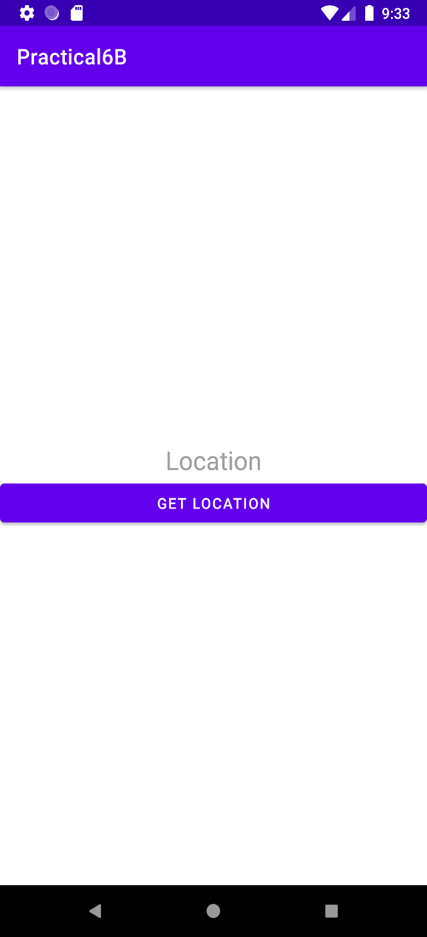 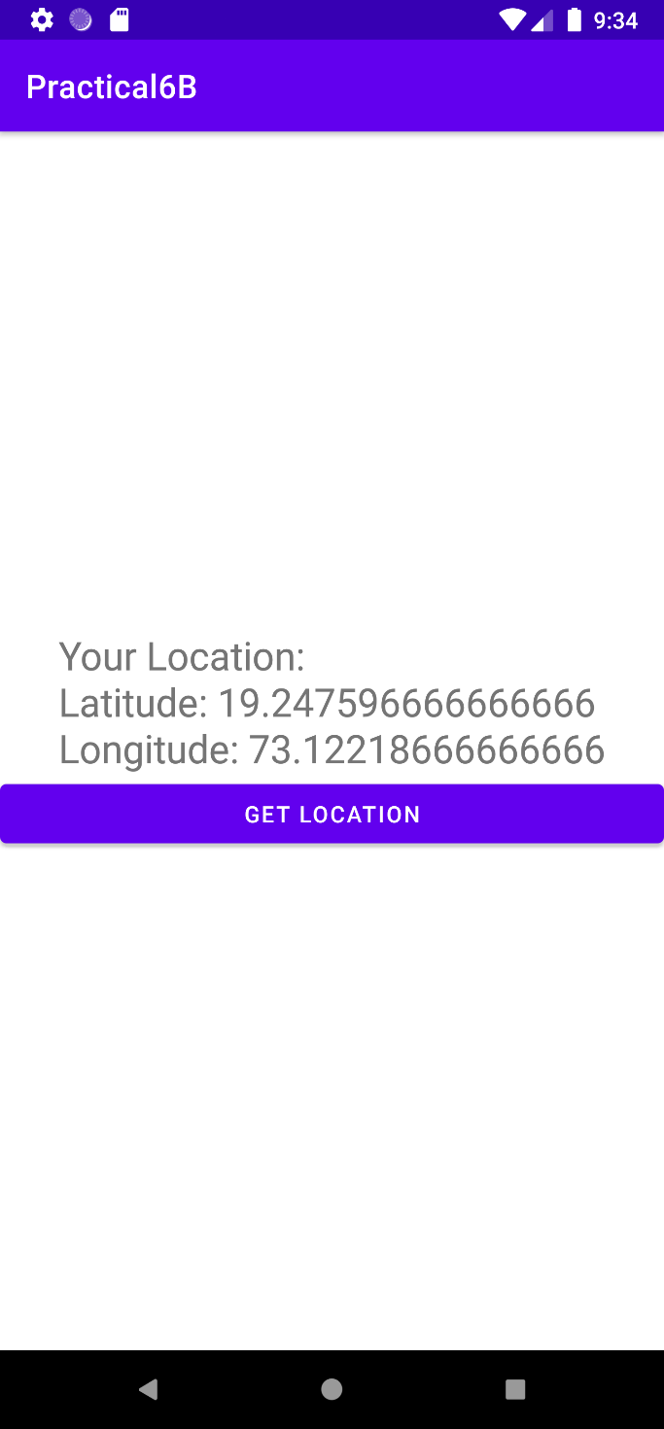

* **CONCLUSION:**

Hence we successfully studied audio, video and location on android.